The Munich Putsch 1923
Streseman gave into France and Belgium and ended passive resistance in the Ruhr. This helped combat hyperinflation but angered many people. Germany appeared weak.

Hitler highlighted Stresemann’s decision as a betrayal. Stresemann had given in to the Allies as the Government had done in 1918 by ending World War One.

Hitler knew that this would be a good time to challenge the government - the people of Germany had been through economic hardship and considered the government to be weak and unable to stand up for Germany and to solve its problems

The Nazis attempted to bring down the government by marching on Munich. They tried to persuade the head of the Bavarian Government – Kustov von Kahr to join them.

Kahr managed to get away from the Nazis after pretending to go along with their plan. He and his most trusted general Lossow contacted the State Police

When Hitler marched on Munich the revolt was crushed with 16 Nazis being killed. Hitler was arrested. The putsch was a failure but it did show that the Government could easily be attacked by extremist groups

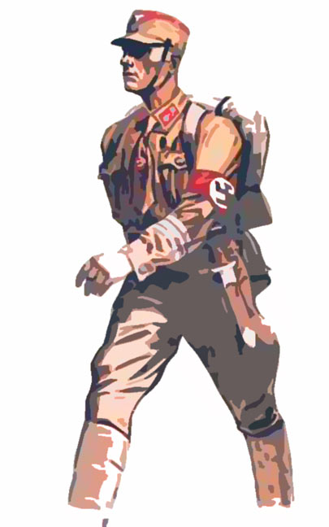

Why did Hitler fail to take Munich?

Hitler lacked sufficient support (The Nazis only had 3000 members)

Ludendorff let Kahr and his colleagues leave the Beer Hall (they raised the alarm)
The Nazis marched through driving snow to confront 100 police officers

Sixteen Nazis were shot and the rest fled – including Hitler who dislocated his shoulder

Many of the Nazi rifles’ firing pins were missing

Ludendorff was arrested on the scene – Hitler was arrested two days later

What did Hitler grab victory out of the jaws of defeat?

Publicity through press coverage of his trial – Hitler became the ‘natural’ leader of The Right Wing

Hitler showed his immense oratory (speaking) skills and political talent
He learnt that the Judges (judiciary) were sympathetic with his arguments and towards The Right Wing (Hitler’s sentence was reduced and other leading Nazis were let off – including Ernst Rohm)
Hitler learnt that it was better to use persuasion rather than force when
attempting to gain power in Germany

Hitler reorganised his Party after 1924. He now recruited younger members, employed Gauleiters to represent the Nazi Party in each region of Germany and used extensive propaganda

